**Supervised ML – Classification 1 (Palmer Penguins Dataset)**

**3.Palmer Penguins**

Colab Link - <https://colab.research.google.com/drive/10xy0ZIxJ5IB8BQdsledRiC3_2bR9IkCd?usp=sharing>

# --- 0. Setup: Import Libraries ---

# Note: MAE, MSE, RMSE, R-squared are for regression tasks and won't be applied here,

# But are crucial for evaluating regression models.

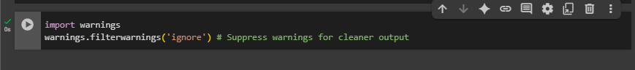

1. **Data Loading & Initial Inspection-**

**# Load the Palmer Penguins dataset from seaborn**

**# Display the first few rows**

**# Get a concise summary of the DataFrame**

**# Check for missing values**

**# Basic descriptive statistics for numerical columns**

1. **Data Cleaning, Preprocessing & Wrangling**

# --- Handling Missing Values ---

# For simplicity in this tutorial, we'll drop rows with any missing values.

# In a real-world scenario, you might impute them (e.g., mean, median, mode, or more advanced methods).

**# --- Feature Engineering (Conceptual) ---**

**# For this dataset, we won't create complex new features, but it's important**

**# to understand that this phase is where you might combine features,**

**# extract information (e.g., from dates), or apply mathematical transformations.**

**# Example: If we had 'year' and 'month' columns, we could engineer a 'season' feature.**

**# Or, if these were images, we'd extract features using CNNs.**

**# --- Encoding Categorical Features ---**

**# 'species' is our target variable (y). 'island' and 'sex' are features (X).**

**# We need to convert these into numerical representations.**

**# Encode the target variable 'species'**

**# Define features (X) and target (y)**

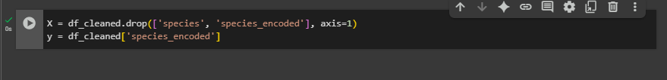

**# Identify categorical and numerical features for preprocessing**

**# Create a preprocessing pipeline**

**# One-hot encode categorical features and scale numerical features**

**# --- Train-Test Split ---**

**# Split the dataset into training and testing sets to evaluate model performance**

**# Apply preprocessing to training and testing data**

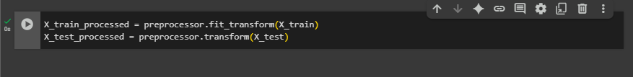

**# Get feature names after one-hot encoding for better interpretability**

**3.Exploratory Data Analysis (EDA) –**

**# Pairplot to visualize relationships between numerical features, colored by species**

**# Correlation Heatmap for numerical features**

**# Distribution of Species**

**# Boxplots of numerical features by species**

**4.Model Training with Different Algorithms**

**# Initialize different classifiers**

**5. Model Evaluation**

**# --- ROC Curve (Multiclass) ---**

**# For multiclass ROC, a common approach is One-vs-Rest (OvR)**

**# We calculate ROC for each class against all others.**

**6. Prediction & Decision Making**

**# Choose the best performing model. In this case, many models achieved very high accuracy.**

**# Let's pick Random Forest as an example, as it's robust.**

**# --- Example Prediction on unseen data ---**

**# Let's create a hypothetical new penguin measurement**

**# (Make sure these values are within a reasonable range for penguins)**

**# Preprocess the new data using the same preprocessor fitted on training data**

**# Make a prediction**

**# If we want the probability distribution:**

**# --- Decision Making ---**

|  |  |  |  |
| --- | --- | --- | --- |
| **#** | **New Data** | **Prediction** | **Decision** |
| **1** | { 'bill_length_mm': 39.5, 'bill_depth_mm': 17.5, 'flipper_length_mm': 190.0, 'body_mass_g': 3500.0, 'island': 'Torgersen', 'sex': 'Male' } | Penguin 1: Predicted Species = Adelie | Adelie |
| **2** | **{ 'bill_length_mm': 46.0, 'bill_depth_mm': 21.0, 'flipper_length_mm': 210.0, 'body_mass_g': 4200.0, 'island': 'Biscoe', 'sex': 'Female' }** | Penguin 2: Predicted Species = Gentoo | Gentoo |
| **3** | **{ 'bill_length_mm': 50.5, 'bill_depth_mm': 15.3, 'flipper_length_mm': 222.0, 'body_mass_g': 5000.0, 'island': 'Dream', 'sex': 'Male' }** | Penguin 3: Predicted Species = Chinstrap | Chinstrap |
| **4** | **{ 'bill_length_mm': 36.2, 'bill_depth_mm': 18.9, 'flipper_length_mm': 181.0, 'body_mass_g': 3200.0, 'island': 'Torgersen', 'sex': 'Female' }** | Penguin 4: Predicted Species = Adelie | Adelie |
| **5** | **{ 'bill_length_mm': 42.1, 'bill_depth_mm': 19.5, 'flipper_length_mm': 200.0, 'body_mass_g': 3800.0, 'island': 'Biscoe', 'sex': 'Male' }** | **Penguin 5: Predicted Species = Adelie** | **Adelie** |
| **6** | **{ 'bill_length_mm': 45.6, 'bill_depth_mm': 20.2, 'flipper_length_mm': 210.0, 'body_mass_g': 3950.0, 'island': 'Dream', 'sex': 'Female' }** | **Penguin 6: Predicted Species = Chinstrap** | **Chinstrap** |
| **7** | **{ 'bill_length_mm': 48.0, 'bill_depth_mm': 16.8, 'flipper_length_mm': 218.0, 'body_mass_g': 4700.0, 'island': 'Biscoe', 'sex': 'Male' }** | **Penguin 7: Predicted Species = Gentoo** | **Gentoo** |
| **8** | **{ 'bill_length_mm': 37.8, 'bill_depth_mm': 18.5, 'flipper_length_mm': 192.0, 'body_mass_g': 3450.0, 'island': 'Torgersen', 'sex': 'Female' }** | **Penguin 8: Predicted Species = Adelie** | **Adelie** |
| **9** | **{ 'bill_length_mm': 41.3, 'bill_depth_mm': 17.7, 'flipper_length_mm': 196.0, 'body_mass_g': 3600.0, 'island': 'Dream', 'sex': 'Male' }** | **Penguin 9: Predicted Species = Adelie** | **Adelie** |
| **10** | **{ 'bill_length_mm': 52.0, 'bill_depth_mm': 20.5, 'flipper_length_mm': 225.0, 'body_mass_g': 5200.0, 'island': 'Biscoe', 'sex': 'Female' }** | **Penguin 10: Predicted Species = Gentoo** | **Gentoo** |

**Conclusion:**

* I learned how to use machine learning to classify data, specifically by analyzing physical characteristics of penguins to predict their species. This project gave me a solid understanding of the entire data science pipeline, from data preprocessing to model evaluation.
* The biggest difficulty I faced was handling the dataset's messy aspects, like missing values and duplicate rows. I had to learn to systematically clean and prepare the data before it could be used for modeling. Another challenge was visualizing high-dimensional data, which I overcame by using dimensionality reduction techniques like PCA.
* Through this project, I gained several key skills, including data cleaning and preprocessing, feature scaling, exploratory data analysis (EDA), and applying unsupervised learning algorithms for classification. I also improved my problem-solving skills and learned to interpret the results of a machine learning model.
* If I were offered a job, I could apply these skills to a wide range of tasks, such as analyzing customer data to identify trends, predicting product demand, or even detecting fraudulent activity by spotting anomalies in a data set. My experience with this project has given me a practical foundation in data analysis that is directly applicable to many real-world business problems.
* This experience has motivated me to continue learning about advanced machine learning topics like deep learning and natural language processing. I’m excited to explore new datasets and build more complex models to solve different kinds of challenges.